What is big data
https://www.sas.com/en_in/insights/big-data/what-is-big-data.html
https://www.udemy.com/course/hadoopstarterkit/

The term “big data” refers to data that is so large, fast or complex that it’s difficult or impossible to process using traditional methods.

- what is considerd big today may not be big after few years, its a moving target
- what is considered big for small company may not be big for company like google or facebook.

Volume of data is not the only factor to clasify the data is big data or not.
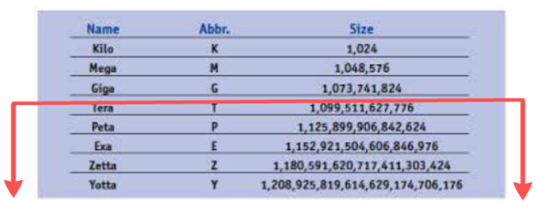

Cosider a example of small startup , whch has recently launched a email service. In 3 months 100K users signed up , current size of data base is 1Tb. This is not a big data 1Tb of data is not big enough to cliasify it as big data problem, with this rate of increase will there be a big data problem?

To check this need check the 3 factor/V’s

Volume: Organizations collect data from a variety of sources, including business transactions, smart (IoT) devices, industrial equipment, videos, social media and more. In the past, storing it would have been a problem – but cheaper storage on platforms like data lakes and Hadoop have eased the burden.
Velocity: With the growth in the Internet of Things, data streams in to businesses at an unprecedented speed and must be handled in a timely manner. RFID tags, sensors and smart meters are driving the need to deal with these torrents of data in near-real time.
Variety: Data comes in all types of formats – from structured, numeric data in traditional databases to unstructured text documents, emails, videos, audios, stock ticker data and financial transactions.

In 3 month the startup has 100K active users and volume is 1 TB. With the same rate at the end of the year there will 400K active users and volume will be 4TB, at end of 2nd year it will be 8TB.
we should not only just think of volume, we should also check the speed at which the data grows “velocity”. if the database stays at 1TB every year, this is not a big data problem only need a good database to handle the load. If the volume increase 1TB every week the need think of scalable big data solution.
Most of time volume and velocity is sufficient to decide if have big data problem or not.
Next factor to consider is the variety,
The data in traditional database is structured, for this startup, this startup need store the text for actual message and images as attachement. When have data comming in different format, and need process/ analyze the data in different formats , traditional data base sure to fail, combined with volume and velocity will have a big data problem.

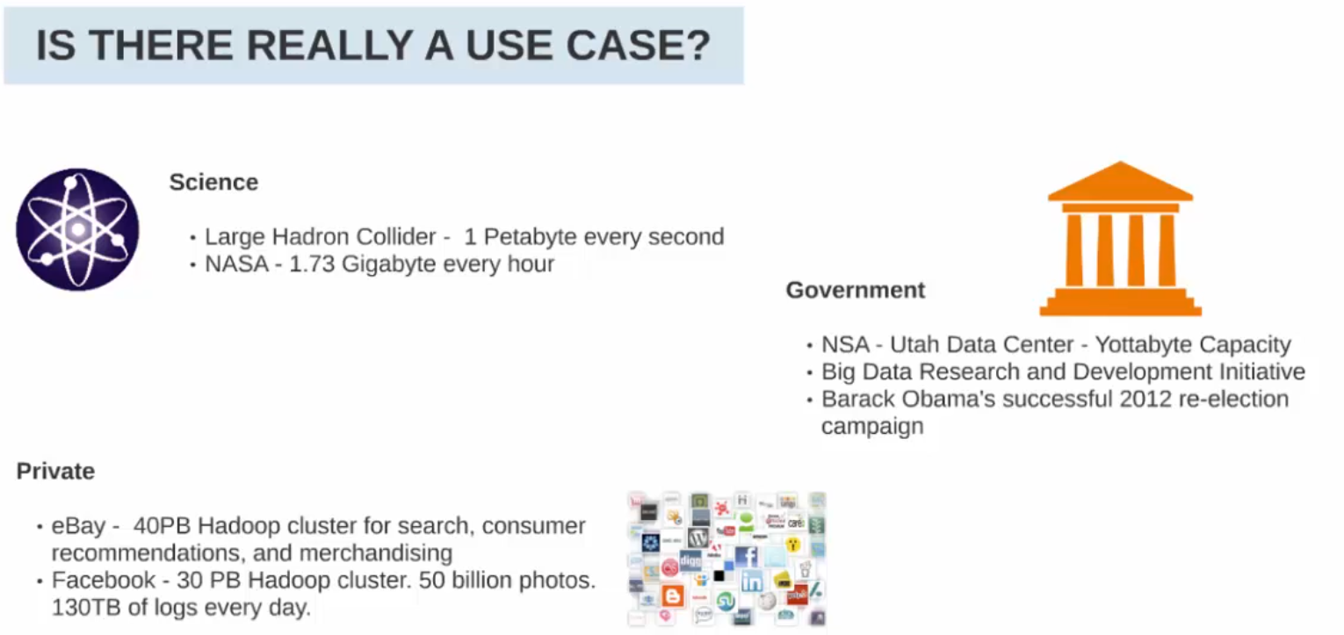

https://open.nasa.gov/blog/what-is-nasa-doing-with-big-data-today/

https://nsa.gov1.info/utah-data-center/
https://www.youtube.com/watch?v=0mgXNgD3JFU
https://gigaom.com/2012/08/22/facebook-is-collecting-your-data-500-terabytes-a-day/
https://www.infoworld.com/article/2613587/the-real-story-of-how-big-data-analytics-helped-obama-win.html

Sources of Big Data
These data come from many sources like:
- Social networking sites: Facebook, Google, LinkedIn all these sites generates huge amount of data on a day to day basis as they have billions of users worldwide.
- E-commerce site: Sites like Amazon, Flipkart, Alibaba generates huge amount of logs from which users buying trends can be traced.
- Weather Station: All the weather station and satellite gives very huge data which are stored and manipulated to forecast weather.
Telecom company: Telecom giants like Airtel, Vodafone study the user trends and accordingly publish their plans and for this they store the data of its million users.
- Share Market: Stock exchange across the world generates huge amount of data through its daily transaction.

Big data challenges

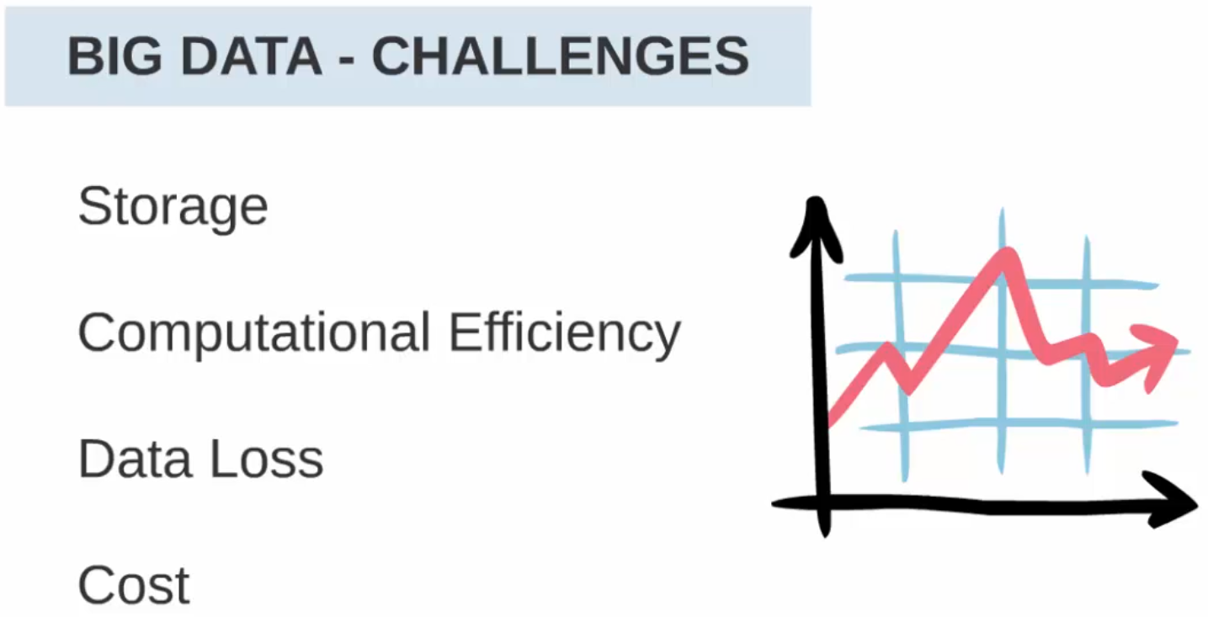

Why big data solution
- Traditional data base is not horizontally scalable, i,e cannot add more hardware to improve the query performance.
- data base are designed to process structured data
- a good data base can be relatively costly for low volume of data.

some distributed computing solutions like grid also have some problems
- grid are good for compute intesive task , not when data volume is huge
- grid computing need low level programming knowledge to implement, cannot be used by every one.

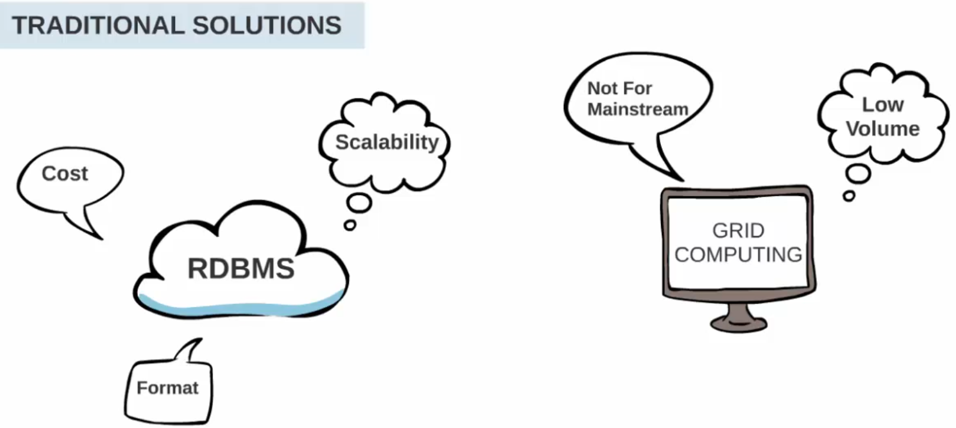

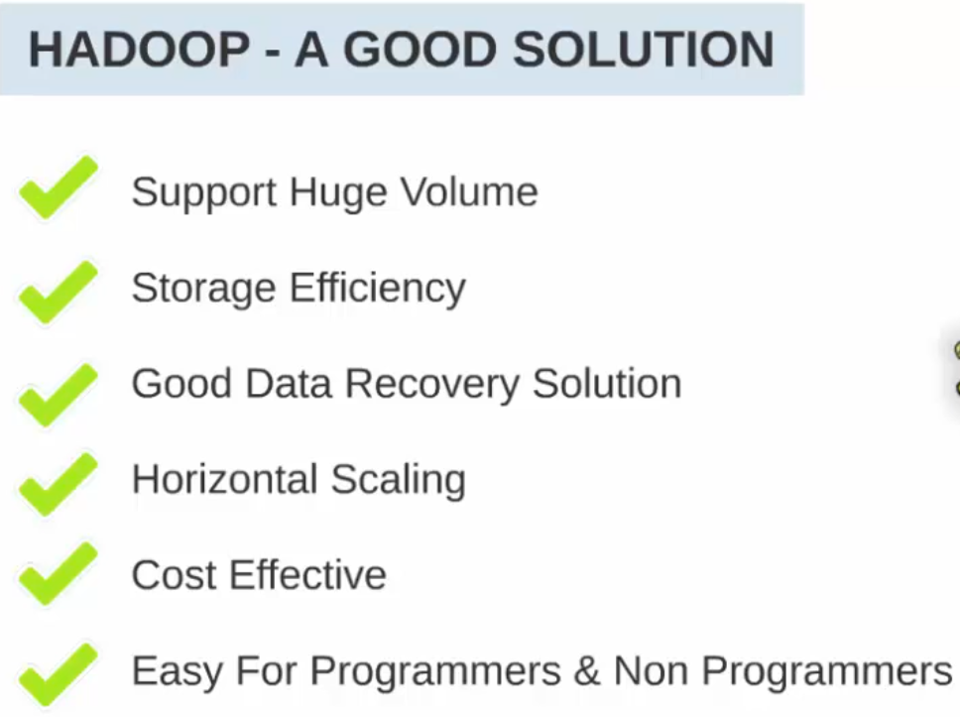

Diffrence HADOOP and RDBMS:
Hadoop is not a replacement for database, there are things where hadoop is good at, and there are things where databse is good at.
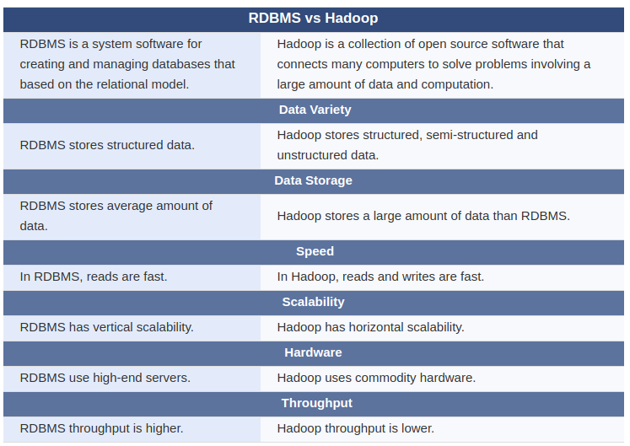
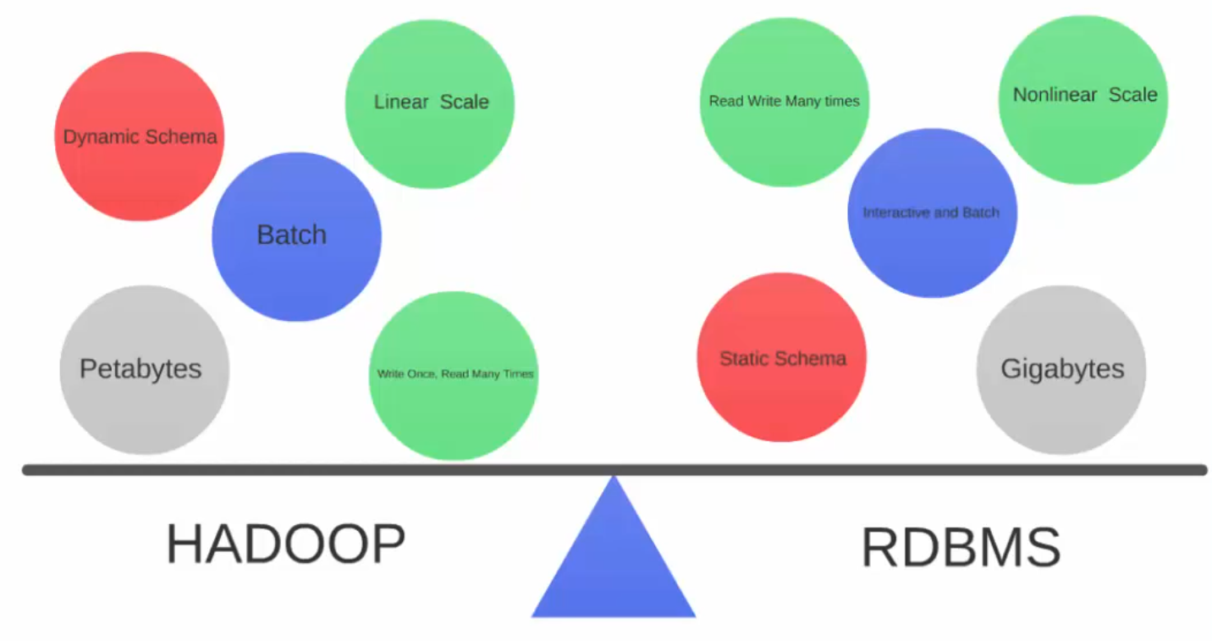

Understanding Big Data Problem
Lets take a sample big data problem and see how to arrive at a solution

Lets assume a person works in a stock exchange, and has been asked to find the maximum closing price for all the stocks within a limited time.

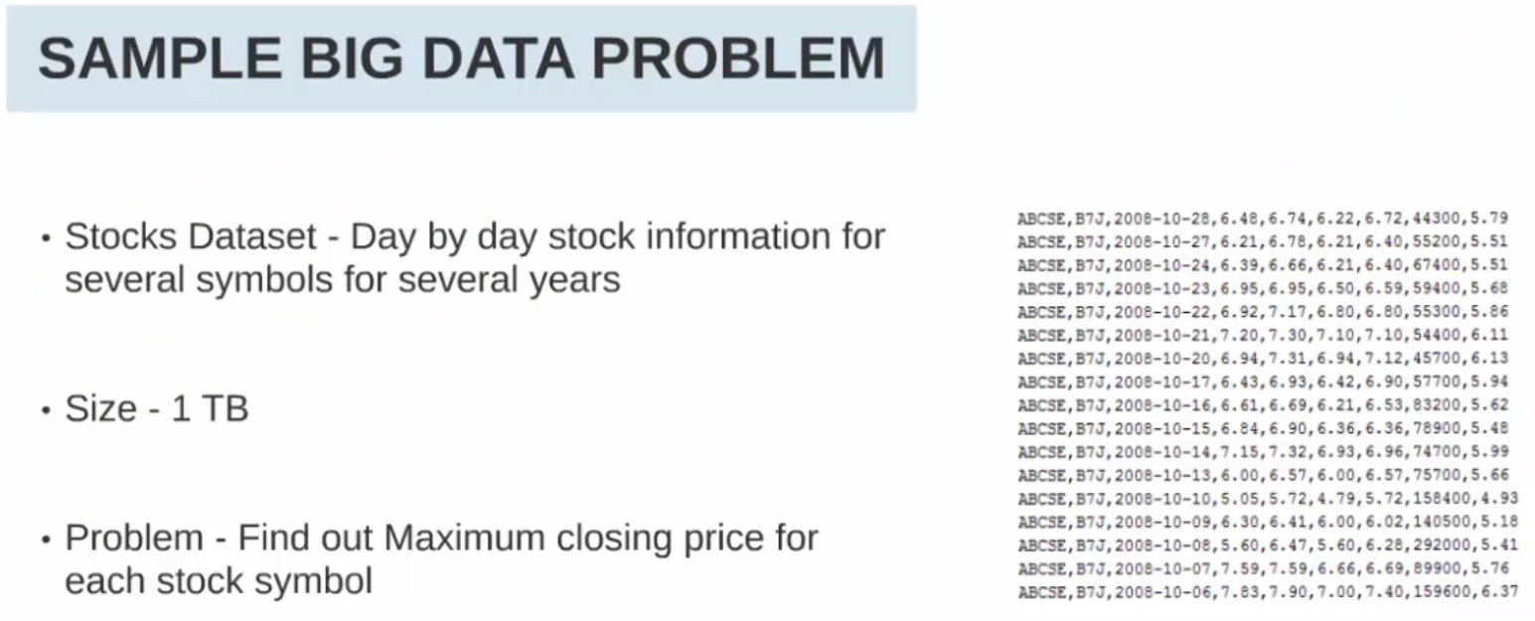

Since the data size is 1TB, it will not be possible to store in normal desktop computer which has the space in GB. So the data is copied to network storage like NAS(Netwrok attached storage)/ SAN(storage area network).
The person writes the code in java or other programming lanuage, but its already running for long, but the processing is still going on. So how to get the approximate time to solve this problem?

An average data access rate from hard disk is 122MB/sec, so to read the 1TB file will take around 2.5 hours.

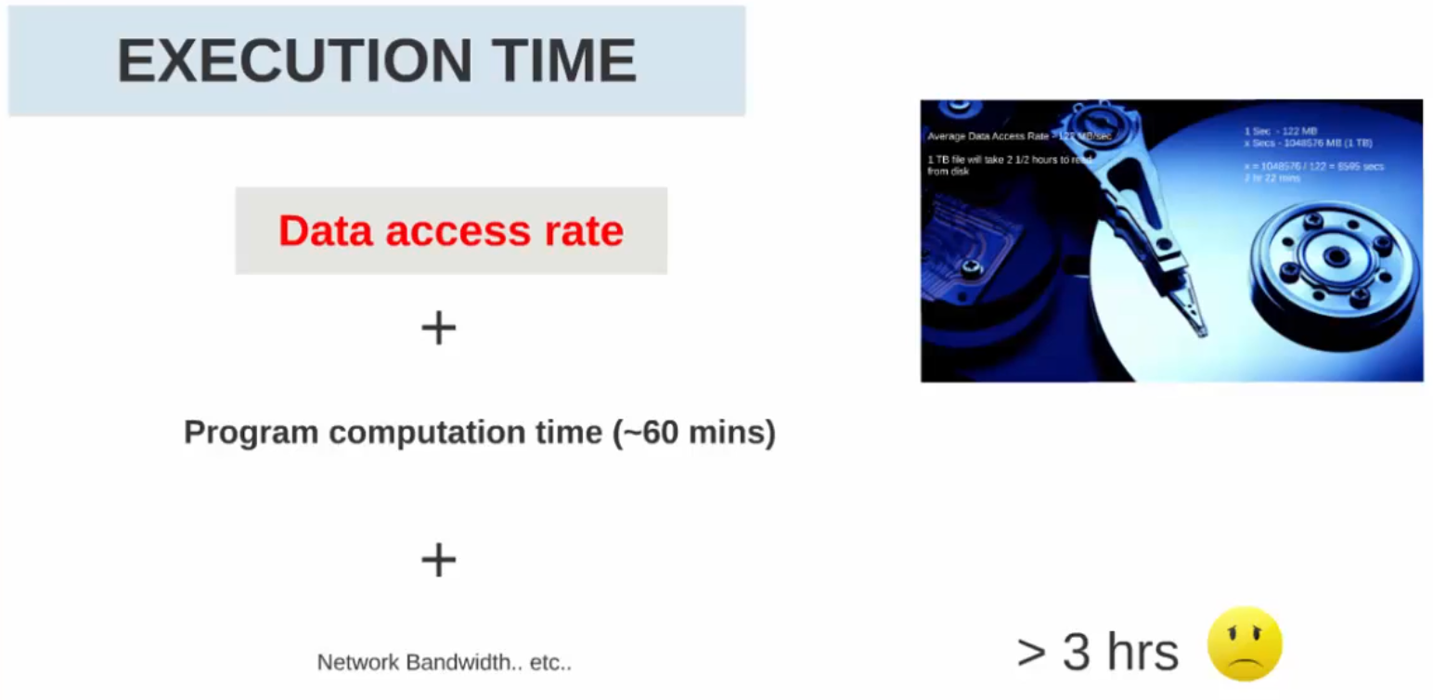

The execution time which is data access rate + computation time + network speed which can be easliy over 3 hrs. This is a lot of time for such a critical work like stock exchange.

Can the speed be improved
There are 2 knows problems
- Transfering the data from hard disk to memory
- Computation time

Solution 1: using SSD (solid state drive), SSD are very fast. By using this the speed of accessing the data will be very fast, but the SSD are very costly.

Solution 2:
What if we divide the 1 TB file to 100 equal size and process them seperately. This will reduce the over all execution time.
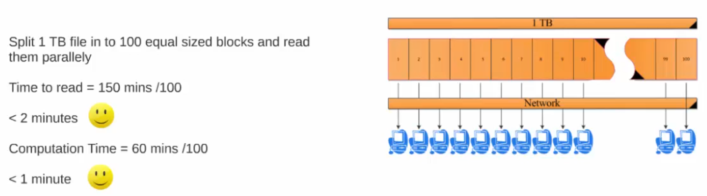

Few problem with this:
- more than 1 chunks cannot be in same machine, since hard disk cannot process all the chunks at same time.
- Assuming there are 100 chunks in 100 machine which are connected over network. So there are 100 * 122 (hard disk speed) per sec data read over network. This wil over load the netwrok, reducing the network speed.

Solution 3:
What if we store the data near the computation, i.e data read and computation done are in the smae machine/node. This will reduce the network usability.
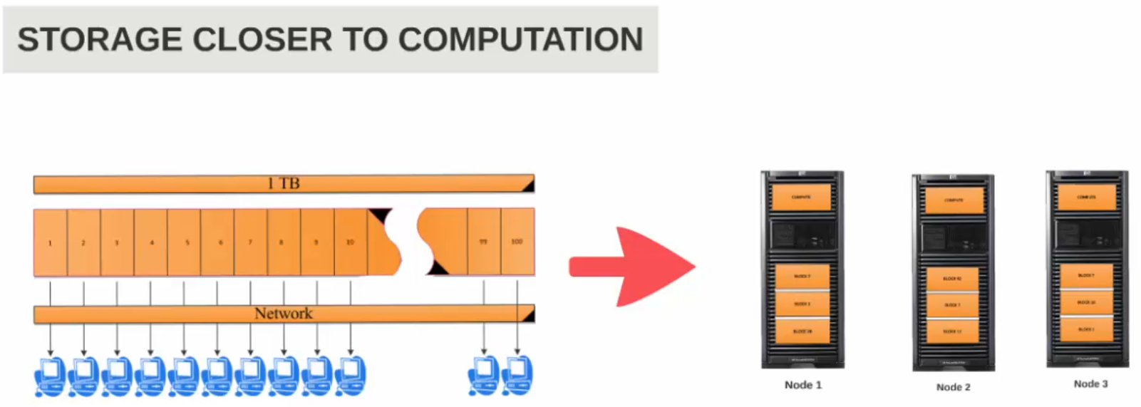

Problem:
Data loss due to hard disk failure, there are always a case where the hard disk can go down causing the data loss., so need to have a data backup in multiple node.

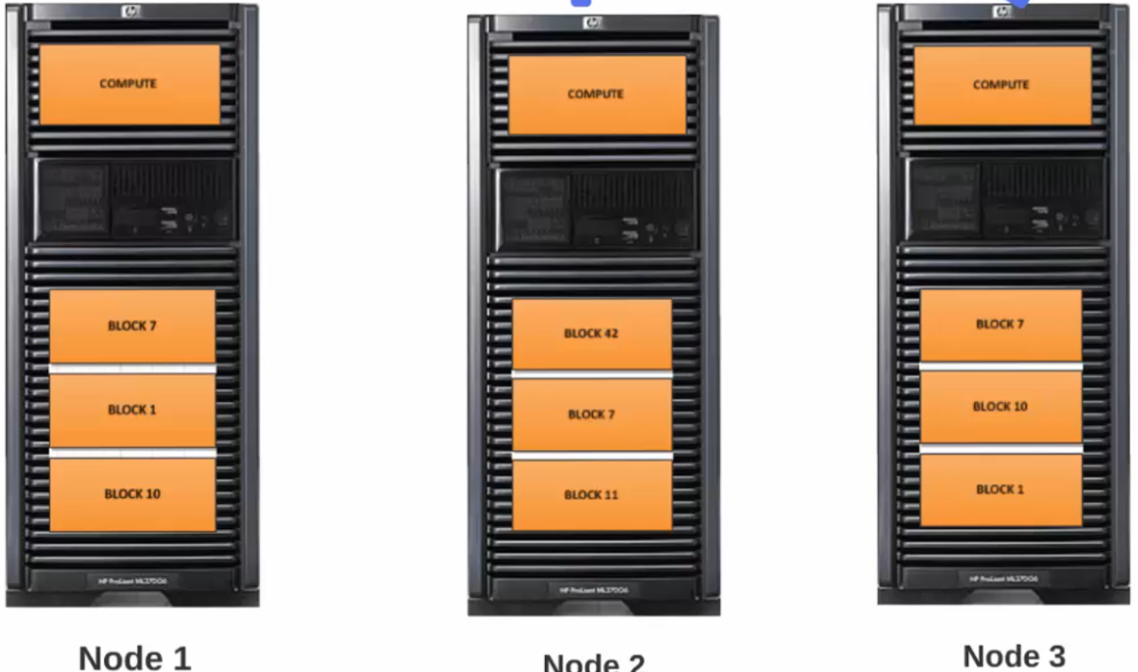

Some chanllenges:
1 Each of the node should maintain the chunks and each node should know which other node have the replica. And all these node should be connected over network.
2 Each node will do the computation on its node, so there should be some on who whould consolidate the result from each node and provide the final output.

Hadoop Final solution
The solution is distributed computing, as we can see there are many chalenge which involves in both at storage layer and also at computational layer.
So the solution is hadoop , it offers a framewrok for distributed computing.
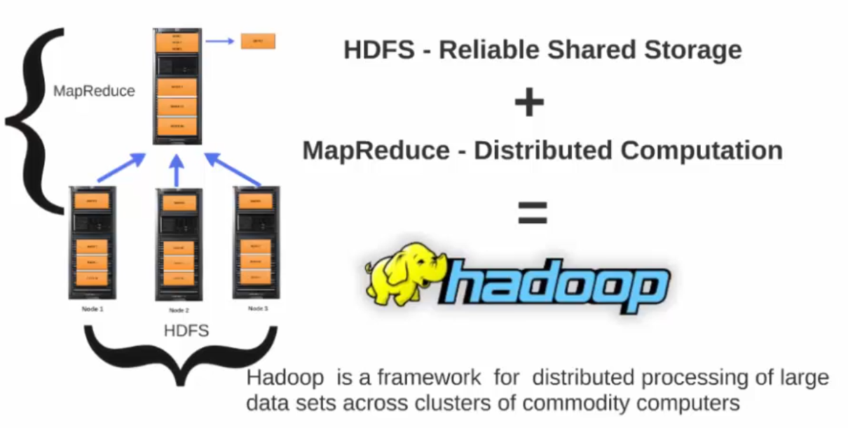

It has 2 core component
HDFS (hadoop distributed file system) - reliable shared storage, this takes care of all storage related complexities
- splitting the data set in to blocks
- relicating the blocks in more than 1 node
- keep track of which node has which block
Etc...
Map reduce - distributed computation - is a programming model
Hadoop implements map reduce
Hadoop framework takes care of bringing intermeiate result from each node to offer a consolidate output

Hadoop is a framework for distribted processing of large data set across clusters of commodity computers.
Commodity computers - they do not need to have a specilized hardware, they are entrprise grade server node ( not a cheap hardware)

Hadoop will horizontalu scale, to improve the speed more nodes can me added.

So this solution can be used by the stock exchange analyzt to get the output in few mintes instead of waiting for many hours

Other Big DATA Technology
https://www.analyticssteps.com/blogs/top-10-big-data-technologies-2020

- No SQL Database
- Apache Spark

There are various technologies in the market from different vendors including Amazon, IBM, Microsoft, etc., to handle big data. While looking into the technologies that handle big data, we examine the following two classes of technology −

Operational Big Data
This include systems like MongoDB that provide operational capabilities for real-time, interactive workloads where data is primarily captured and stored.
NoSQL Big Data systems are designed to take advantage of new cloud computing architectures that have emerged over the past decade to allow massive computations to be run inexpensively and efficiently. This makes operational big data workloads much easier to manage, cheaper, and faster to implement.
Some NoSQL systems can provide insights into patterns and trends based on real-time data with minimal coding and without the need for data scientists and additional infrastructure.

Analytical Big Data
These includes systems like Massively Parallel Processing (MPP) database systems and MapReduce that provide analytical capabilities for retrospective and complex analysis that may touch most or all of the data.
MapReduce provides a new method of analyzing data that is complementary to the capabilities provided by SQL, and a system based on MapReduce that can be scaled up from single servers to thousands of high and low end machines.
These two classes of technology are complementary and frequently deployed together.

